Project Design Overview
This document outlines the design for the Leave Request Approval System. It builds upon the project plan and provides detailed requirements, system architecture, development methodology, risk assessment, and evaluation criteria. The goal of this design document is to provide a clear roadmap for the successful development and delivery of the system.
1. Project Requirements
1.1 Functional Requirements
Functional requirements describe the core features and behaviors of the Leave Request Approval System. These requirements define what the system must do to meet user needs.
Employee Requirements
The system shall allow employees to:
- Submit leave requests
- Select leave type (vacation or personal)
- Choose start and end dates for leave
- View leave request status
- View request history
- Receive feedback when a request is rejected or revision is requested
Manager Requirements
The system shall allow managers to:
- View submitted leave requests
- Approve leave requests
- Reject leave requests
- Request revisions with comments
- View scheduling conflicts
- View team calendar of approved leave
- View request history
System Requirements
The system shall:
- Track request status (Pending, Approved, Rejected, Revision Requested)
- Store leave request data in a database
- Support role-based access (Employee and Manager)
- Allow users to log in securely (if time allows)
- Maintain request history

1.2 Non-Functional Requirements
Non-functional requirements define how the system performs rather than what the system does.
Performance Requirements
- The system should load pages within 2 seconds
- The system should handle multiple users simultaneously
- The system should respond quickly to request submissions
Security Requirements
- User data must be protected
- Passwords must be stored securely using hashing
- Role-based access control must be implemented
- Only authorized users may access system features
Usability Requirements
- The interface should be simple and intuitive
- The system should be easy to navigate
- Forms should be clear and user-friendly
Reliability Requirements
- The system should prevent data loss
- The system should maintain request history
- The system should handle errors gracefully
2. Project Methodology
The Leave Request Approval System will follow an Agile development methodology. Agile is well suited for this project because of the short development timeline and the need for flexibility during implementation. The team will work in phases, allowing core features to be developed first, followed by additional features if time allows.
The project will be divided into the following phases:
- Planning and Design
- Development Phase 1 (Core Features)
- Development Phase 2 (Integration and Additional Features)
- Testing
- Documentation and Final Delivery
Using Agile allows the team to focus on delivering a working system early in development. Core functionality such as submitting leave requests, approving or rejecting requests, and status tracking will be prioritized. Additional features such as leave balance tracking, calendar views, and conflict detection will be implemented if time permits.
The team will use iterative development and continuous communication to monitor progress and adjust as needed. Microsoft Teams will be used for communication, and GitHub will be used for version control and collaboration. Regular check-ins will help ensure that tasks are completed on time and any issues are addressed quickly.
3. Work Breakdown Structure (Project Tasks)
The Leave Request Approval System project will be divided into manageable tasks to ensure efficient development and clear responsibility. The work breakdown structure follows the phased project schedule defined in the project plan.
Phase 1: Planning and Design
- Finalize project scope and requirements
- Define system architecture
- Design UML diagrams and class structure
- Design database schema
- Define API endpoints
- Set up project repository
- Set up development environment

Phase 2: Backend Development
- Create User model
- Create LeaveRequest model
- Implement request submission endpoint
- Implement request retrieval endpoint
- Implement request approval endpoint
- Implement request rejection endpoint
- Implement request status updates
- Implement database integration
- Implement validation and error handling

Phase 3: Frontend Development
- Create employee request form
- Create manager dashboard
- Create request history view
- Create status display components
- Create team calendar view (if time allows)
- Implement frontend validation
- Connect frontend to backend API

Phase 4: Integration
- Connect frontend to backend
- Test API endpoints
- Resolve integration issues
- Validate data flow
- Implement additional features (if time allows)

Phase 5: Testing
- Create test plan
- Write test cases
- Perform unit testing
- Perform integration testing
- Fix bugs
- Validate system functionality

Phase 6: Documentation and Final Delivery
- Write user guide
- Prepare final report
- Prepare presentation
- Final system review
- Final submission
4. Project Schedule
The Leave Request Approval System will follow a phased schedule to ensure timely development and delivery. The schedule allows overlapping development and testing to maximize productivity within the limited timeline.
Phase 1: Planning and Design (March 24 — March 30)
- Finalize project scope and requirements (March 24 — March 26)
- Design UML and class diagrams (March 26 — March 28)
- Set up project repository and development environment (March 28 — March 30)

Phase 2: Development (March 31 — April 20)
Phase 2.1 Core Development (March 31 — April 9)
Backend Development:
- Create database schema
- Create User and LeaveRequest classes
- Implement API endpoints
- Implement request workflow logic
Frontend Development:
- Create employee request form
- Create manager dashboard
- Create request history views

Phase 2.2 Integration and Additional Features (April 10 — April 20)
- Connect frontend to backend
- Implement additional features (if time allows)
- Fix integration issues
- Improve UI and system functionality

Phase 3: Testing (April 14 — April 27)
- Unit testing
- Integration testing
- Bug fixes
- User acceptance testing

Phase 4: Documentation and Final Delivery (April 28 — May 4)
- Final report
- User guide
- Final presentation
- Final submission
5. Project Risks and Mitigation Plan
The following risks have been identified for the Leave Request Approval System. These risks may impact development progress, system functionality, or project completion. Mitigation strategies have been developed to reduce potential impact.
Risk 1: Short Development Timeline
Description:
The project timeline is limited to approximately six weeks, which may create challenges when implementing all planned features.
Impact: High
Probability: High
Mitigation Strategy:
- Prioritize core functionality first
- Identify stretch features that can be removed if needed
- Use phased development approach
- Conduct regular progress check-ins

Risk 2: Team Scheduling Conflicts
Description:
Team members may have different schedules and time zone differences that could impact collaboration.
Impact: High
Probability: High
Mitigation Strategy:
- Use asynchronous communication
- Document decisions in writing
- Schedule flexible meeting times
- Provide regular updates in Teams or Discord

Risk 3: Technical Challenges
Description:
Some team members may be unfamiliar with parts of the technology stack, which could slow development.
Impact: Medium
Probability: Medium
Mitigation Strategy:
- Assign tasks based on strengths
- Allow time for learning
- Support knowledge sharing among team members
- Keep architecture simple

Risk 4: Integration Issues
Description:
Frontend and backend components may not integrate properly if developed independently.
Impact: High
Probability: Medium
Mitigation Strategy:
- Define API endpoints early
- Begin integration early
- Test integration continuously
- Communicate frequently between frontend and backend

Risk 5: Scope Creep
Description:
Additional features may be requested during development, causing delays.
Impact: Medium
Probability: Medium
Mitigation Strategy:
- Define core features early
- Treat additional features as stretch goals
- Follow change control process
- Prioritize required functionality
6. Project Evaluation Plan
The project evaluation plan defines how the Leave Request Approval System will be assessed throughout development and upon completion. The evaluation will focus on functionality, usability, reliability, and successful completion of project objectives.
Functional Evaluation
The system will be evaluated based on successful implementation of core features, including:
- Employees can submit leave requests
- Managers can approve or reject requests
- Request status updates correctly
- Users can view request history
- System stores data properly in the database
Successful completion of these features will indicate that the system meets functional requirements.

Performance Evaluation
The system will be evaluated based on performance criteria, including:
- System loads within acceptable time
- Requests are processed efficiently
- System handles multiple users without crashing
- Data retrieval is responsive
These criteria help ensure the system performs reliably.

Usability Evaluation
The system will be evaluated for usability using the following criteria:
- User interface is intuitive
- Navigation is simple and clear
- Forms are easy to complete
- Users can complete tasks without confusion
Feedback from team members will be used to identify usability improvements.

Testing Evaluation
Testing will be conducted throughout development and during final phases:
- Unit testing for backend functionality
- Integration testing for frontend and backend
- User acceptance testing for system usability
- Bug tracking and resolution
Successful testing ensures system reliability and stability.

Project Completion Criteria
The project will be considered successful if:
- Core functionality is implemented
- System operates without major errors
- Documentation is completed
- Final presentation is delivered
- Project deadlines are met

7. System Design
7.1 UML Class Diagram
The UML class diagram represents the core structure of the Leave Request Approval System. The system includes two primary classes: User and LeaveRequest. A user can submit multiple leave requests, and each leave request is associated with a single user.
User Class
Attributes:
- userId : int
- name : string
- email : string
- role : string
LeaveRequest Class
Attributes:
- requestId : int
- userId : int
- startDate : date
- endDate : date
- leaveType : string
- status : string
- comments : string
Relationship:
- One User can submit multiple LeaveRequests
- Each LeaveRequest belongs to one User
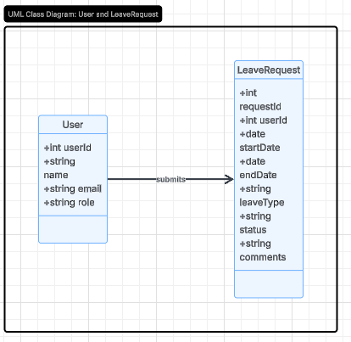
Figure 1. UML Class Diagram for Leave Request Approval System

7.2 Data Model
The data model defines the database structure for storing system data. The Leave Request Approval System includes two main tables: Users and Leave_Requests.
Users Table
Column | Type | Description
user_id | INT | Primary Key
name | VARCHAR | User name
email | VARCHAR | User email
role | VARCHAR | User role (Employee/Manager)
Leave_Requests Table
Column | Type | Description
request_id | INT | Primary Key
user_id | INT | Foreign Key referencing Users
start_date | DATE | Leave start date
end_date | DATE | Leave end date
leave_type | VARCHAR | Leave type
status | VARCHAR | Request status
comments | TEXT | Manager comments
Relationship:
- One user can have multiple leave requests
- Leave requests are linked using user_id
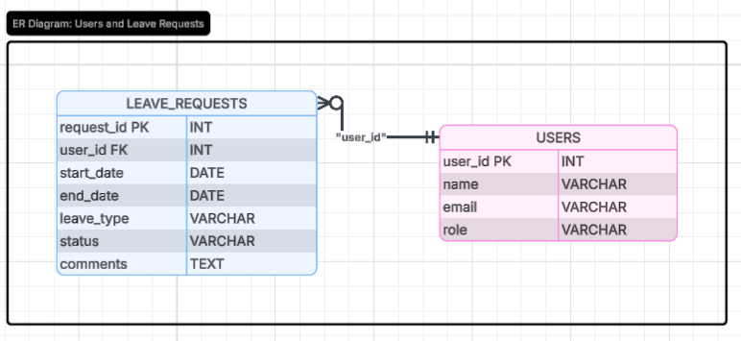
Figure 2. Database Data Model for Leave Request Approval System

